Magdalena Agata Wójcik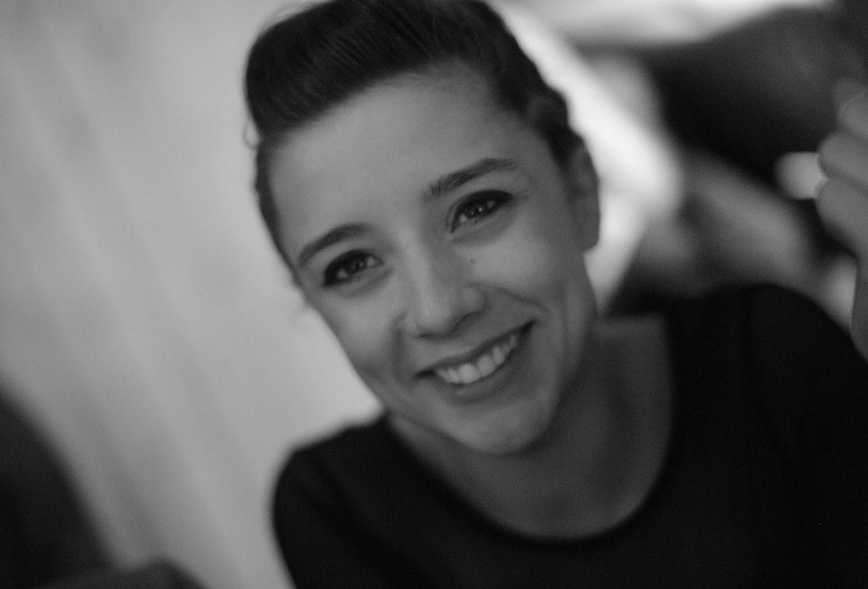
23.10.1991 Warsaw/Poland
Languages: English, Italian
Contact number: 393200932256
Email: magdadancepl@gmail.com
Place of living: Padova/Italy

Education:
2017 Course of Professional Dance Training; Padova
2016- 2017 Roberto Zappala’s 4 months project: “MODem AD” ; Catania/Sicily
2015- 2016 Roberto Zappala’s 8 months project: “MODem AD” ; Catania/Sicily
2013- 2015 University of Social Sciences and Humanities; Sopot/Poland
Department: Psychology
2012 Contemporary dance instructor training; Egurolla Dance Studio;Warsaw/Poland

Compagnies:
2018 Esperimenti Dance Company; Federica Galiberti
2017 Project OFFBEAT.lab; Padova Danza
2016- 2017 Compagnia Petranura Danza; Salvatore Romania (IT), Laura Odierna (IT)
2013 - 2015 Sopot Dance Theatre; Joanna Czajkowska (PL), Jacek Krawczyk (PL)

Performances:
2018 “Hopera” Esperimenti Dance Company
2018 “Quanto basta” Esperimenti Dance Company
2018 “Il Bolero” Milena Zullo
2018 “Mono” Itamar Serussi
2018 “Tre/14” Déjà Donnè
2018 Compagnie Voix progetto “Eve — dance is an unplaceable place”
2017 “Trittico d’autore” Sharon Fridman, Paolo Mohovich, Valerio Longo
2017 “EdipoRe- Into the Mirror” Salvatore Romania (IT) and Laura Odierna (IT)
2016 “Furia” Davide Sportelli (IT)
2016 “FORMal” Natalia Iwaniec (IT, Izrael)
2016 “Walkabout” Elia Mrak (USA), Nancy Lopez (Mexico)
2015 “36,5” Magdalena Wójcik (PL), Joanna Czajowksa (PL)

Teacher experience:
2018 Padova Danza
2017- 2018 Art Gymn; Bologna
2012 Dance School TAZARO; Kamila Guzowska; Poland/Warsaw
2013- 2015 Sopot Dance TheatreYoung Company; Poland/Sopot

Choreography experience:
2018 “Agata In Rosso”; premier Poland
2016 - “Twenty five”; premier Scenario Publico; Catania
2016 - “Circles”; premier Scenario Publico; Catania
2015 - “Coffe and cigarettes”; premier Poland Sopot Dance Theatre
2015 - “WomenCollage”; premier Klub Żak Poland Gdańsk

Workshops:
Itamar Sarussi, Sharon Fridman, David Zambrano, Valerio Longo, Roberto Zappala, Giovanni Scarcella, Loris Petrillo, Francesca Pennini, Milena Zullo, Virginia Spallarossa, Federica Galiberti, Paolo Mohovich, Ming Poon, Maud de la Purification, Ilenia Romano

